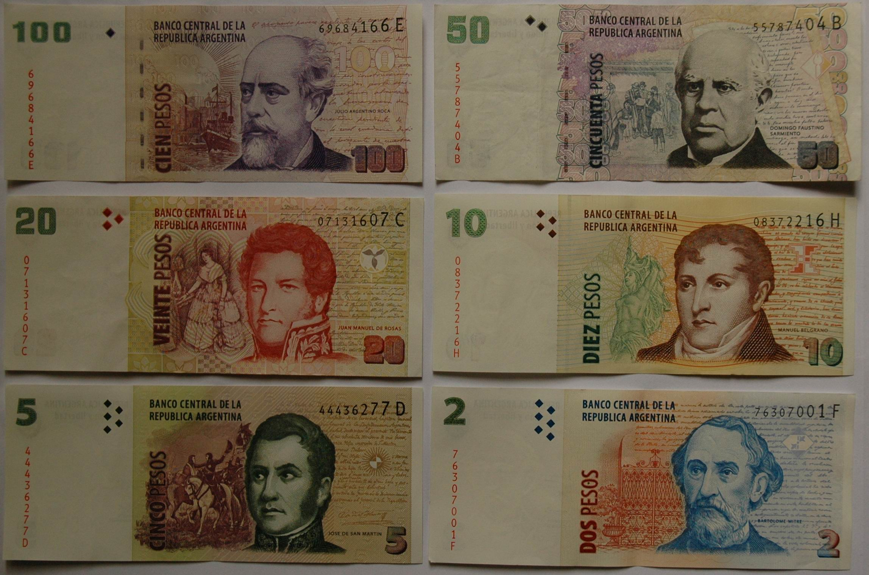
ARGENTINE CURRENCY

